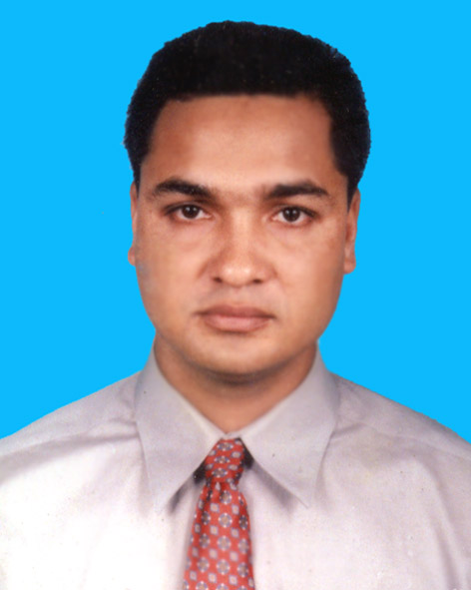
Curriculum Vitae of
Md. Rafiqul Islam
Mailing address: Sun montogo,
House#20, Road#10, Sector-10 Uttra, Dhaka
Email: rafiq_jia@yahoo.com
Cell: +8801730405407, 01795599571
Present Salary: 1,30,000 TK+ others. With mobile and full time Car facility.

Career Objective

To obtain the position in leadership where I am and where success comes through creativity, hard working, sincerity and devotion to duty.

JOB EXPERIENCE ( 12.01 YEARS)

2. Company Name: Runner Automobiles Ltd. Runner is a Group of companies (100% Sales Oriented Company). Runner Automobiles Ltd. Runner Motors Ltd. Runner Bricks Ltd. Runner Properties Ltd. Runner Tera Motors Ltd. Runner System Technology, Barandra University, Rajshahi, newly introduce lubricant and gas ltd).

Company Address: 138/1, Tejgaon Industrial Area, Dhaka-1208.www.runnerbd.com.
.
ACHIEVEMENT: 10% EFFICIENCY INCREASES OF SALES ONLY BY PROPER PLANNING & INTRODUCING NEW IDEA FOR DEALER. I HAVE ACHIEVED ALL YEAR TARGET IN MY (COMPANY) CAREER SO THAT I GOT FOREIGN TOUR INDIA-2008, SINGAPORE-2009, CHINA-2010, THAILAND-2011, MALAYASIA-2012 and 2015, NEPAL-2013 and 2016, THAILAND-2008 and 2014 In Addition I have achieved 02 special Target that was 01 months and 02 months target 01 month Target I have got family tour to Cox’s Bazar by air (This was Record still no one get this type of tour of this company my designation was Asst.Manager) and 02 months Target I got Swaziland Tour.
Designation:

• “National Sales Coordinator” Sales (01st June’17 to Continue)
• “Deputy.Manager” Sales (01st January 2017 to May’17)
• “Asst.Manager” Sales (01st January 2014 to December 16)
• “Sr.Executive” Sales (01st January 2010 to December 2013)
• “Executive” Sales (7th August 2006 to December 2009)
Area Coverage: All Bangladesh Dealer and Showroom Sales.

Posting Place: Head Office, Dhaka.

Key Responsibilities:
Planning for all type of yearly budget, dealer sales policy, LC planning. Act to achieve over all Company Target, Monitoring 06 Zonal Manager who are handling all dealer and Showroom Sales help them for Achieving their individual Sales and Recovery Target of the assigned area, Monitoring others Department like Showroom Admin, MIS, Document Department, factory Production and delivery Section. Monitor Factory, dealers and showroom stock. Keep close eyes on the competitors activities, Keep the market information up to date, Assist the dealer when they face any kind of difficulties, Develop a good relationship with the dealer, dealer staff, Showroom Manager and also assist them in their periodical jobs, Extend the relationship in own area(s) with the non-dealer and explore new sales opportunities, Arrange promotional campaigns and training program, provide all types of daily reports and monthly reports to the supervisor (MD&CEO), Ensure timely delivery of sales documents, To ensure prompt remedial actions regarding customers complaints with due care. Maintain all type of communication with others department.

1. Company Name: ARDENT LTD (100% Medical Equipment Sales Oriented Company).
• ̋Executive”Sales: (15th March, 2006 to 4th August 2006)
Company Address: House # 11, Road# 07, Dhanmondi R/A, Dhaka-1205.

ACHIEVEMENT: 02 Ultra Sound Machine sold within three months yearly target only 04.

Taking training on the following topics:
03 days training “Basic concept of Sales” by Roots and shoots, India.
03 days Training “Basic Concept of Salesmanship and Marketing” by Briddhi, Bangladesh. Handling Customer Complain. Motorcycle Registration Procedure. Product Knowledge of Motorcycle). Profit and loss Account, Development of professional Selling Skills, Etc.

EDUCATION

Post Graduation: Master of Business Administration (MBA).
• Major- Marketing.
• University-International Islamic University Chittagong, Dhaka Campus.
• Year- September 2005 (Grade-A, CGPA-3.825).

Graduation: From March 1999 to June 2002.
B.Sc in Computer Science.
• Institute- East West Collage of Management Studies.
• University- Bangalore University (India)
• Year-2002. Second Class.

Higher Secondary Certificate: From 1996 to 1997
College: Syed Altafunessa Degree College, Khetlal, Joypurhat.
Section: Science, First Division.
Secondary School Certificate: From 1994 to 1995
School: Kalai Moin Uddin High school
Section: Science, First Division.

Communication Skill
Good written and oral communication aptitude in both Bengali and English and Hindi only oral communication.

Hobbies

• Internet , Reading, Music, Travel Etc.

Personal Details

Name : Md. Rafiqul Islam
Date of Birth : 21st January, 1979
Place of birth : Joypurhat
Sex : Male
Nationality : Bangladeshi
Religion : Muslim (Sunni)
Height : 5 feet, 6 inc
Marital status : Married

Extra Curricular Activities

Cricket, Football, Kabadi, Badhan Blood Donor.

Contact Address

Mailing Address |  | Md. Rafiqul Islam  Sun Montogo,  House#20, Road#10, Sector-10 Uttra, Dhaka
Permanent Address  Father’s name:  Mother’s name: |  | Md. Rafiqul Islam  Md. Ayub Ali  Nurun Naher Begum  Vil. Kathail Gopinathpur,P.O.Khetlal, P.S. Kalai  District: Joypurhat, Bangladesh.

Sincerely yours-
 Date: 21-01-2020 Signature
References

• Dr. Mohammad Mannan
Professor & Chairman,
Department of Management Studies,
University of Dhaka.
Phone: 96619200-60 (Ext-4633)

• Md.Mamunur Rashid
Managing Director
Keystone Corporation
Ena Tower ( 6th Floor)
57/3 &57/4 Panthopath
Lake Circus Kalabagan,Dhaka.
Mob: 01531994722
Email: p_mamun@yahoo.com

